## iscMerchant

Demo date: Mar 11, 2025  
Scoping start date:

MSA Signature Date: Mar 14, 2025  
Onboarding Kick Off Date: Mar 17, 2025

[If Exists] Opt Out Date:   
Go Live Date: Ideally send out their first invoice by Apr 1, 2025

GTM POC: Paula  
Implementation POC: Dani

ERP: QBO

Tax Integration: No Tax

### 

### Key people at Merchant

### Accountant: Dan from Attivo, Cal from Attivo

### CFO: None

### Customer service rep who is really involved: None

* Account Receivable POC: Dan
* Billing POC: Dan, previously Muskaan <https://www.linkedin.com/in/muskaan-bawa>

### Head of Rev Ops: Phil <https://www.linkedin.com/in/phil-z-70483832>

### 

| Notes Sections [Ops International Team to Ignore] *(AE/ Implementation to fill)*   * Info on how merchant bills   + Flat price for certain amount of licenses   + future state- usage (launching mid-year) they have no idea what they want it to look like * Is there any important merchant relationship information? There’s no accounting or finance person at Ivo. Previously Muskaan (head of recruiting– yeah, crazy… i know), was doing the billing. They just brought on Phil- Head of Rev ops, who has been involved in the eval. Dan and Cal are the main end users– they’re from Attivo.  1) What is the merchant temperament? Phil defers to Muskaan… he sorta seems like a pushover tbh Phil likes that we can push Tabs data into SFDC for AMs   2) Is there a key POC: (i.e.: who is the buyer/decision maker?) Phil, Cal, Dan, Muskaan (although Muskaan will no longer be that involved)  3) What are the Tabs features that the key POC cares about?   1. Automatic invoice creation 2. Automated dunning 3. Automated cash app 4. Contracts in a central repository 5. Auto update to invoices based on amendments (lots of mid term amendments) 6. CS/sales visibility in SFDC (sfdc <>Tabs integration) |
| --- |

### Company summary *(AE to fill)*

Summary of what company does:  
​Ivo.ai is an AI-powered contract review platform designed to enhance the efficiency and accuracy of legal teams during contract negotiations.

Goals (North star)  
*(AE/ Implementation to fill)*

What is the merchant's goal? What pain are we solving? Why are they buying Tabs?  
  
Pains:  
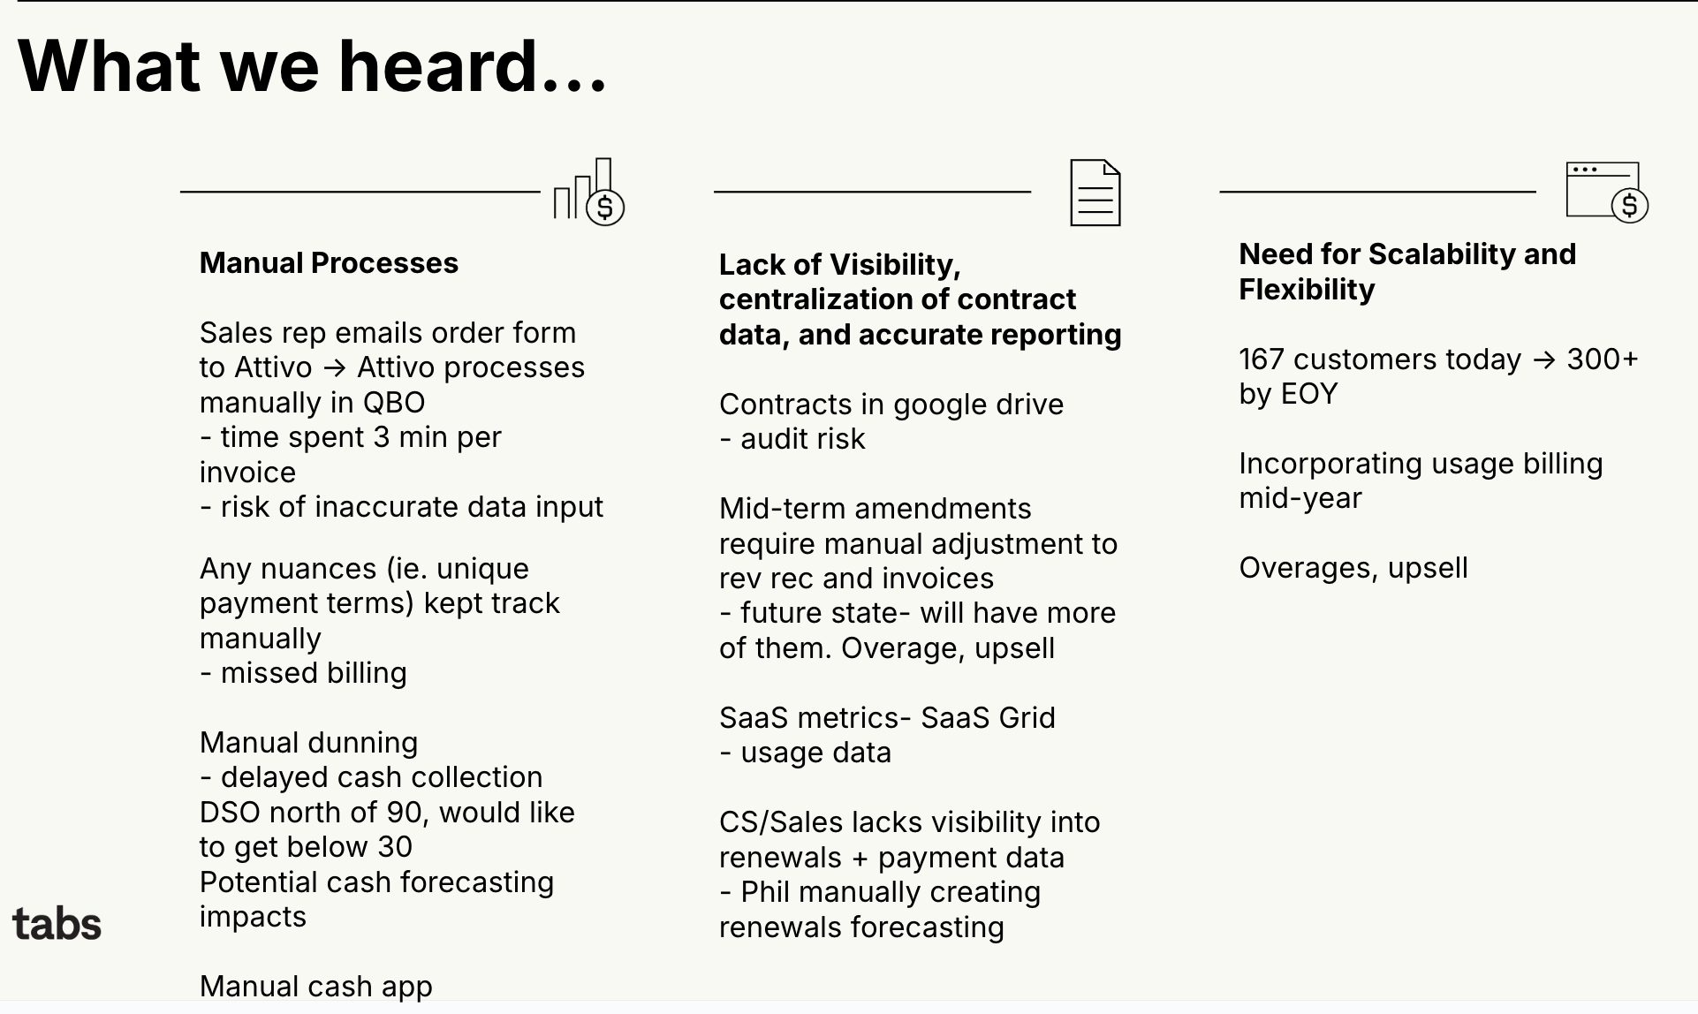

Goals:  
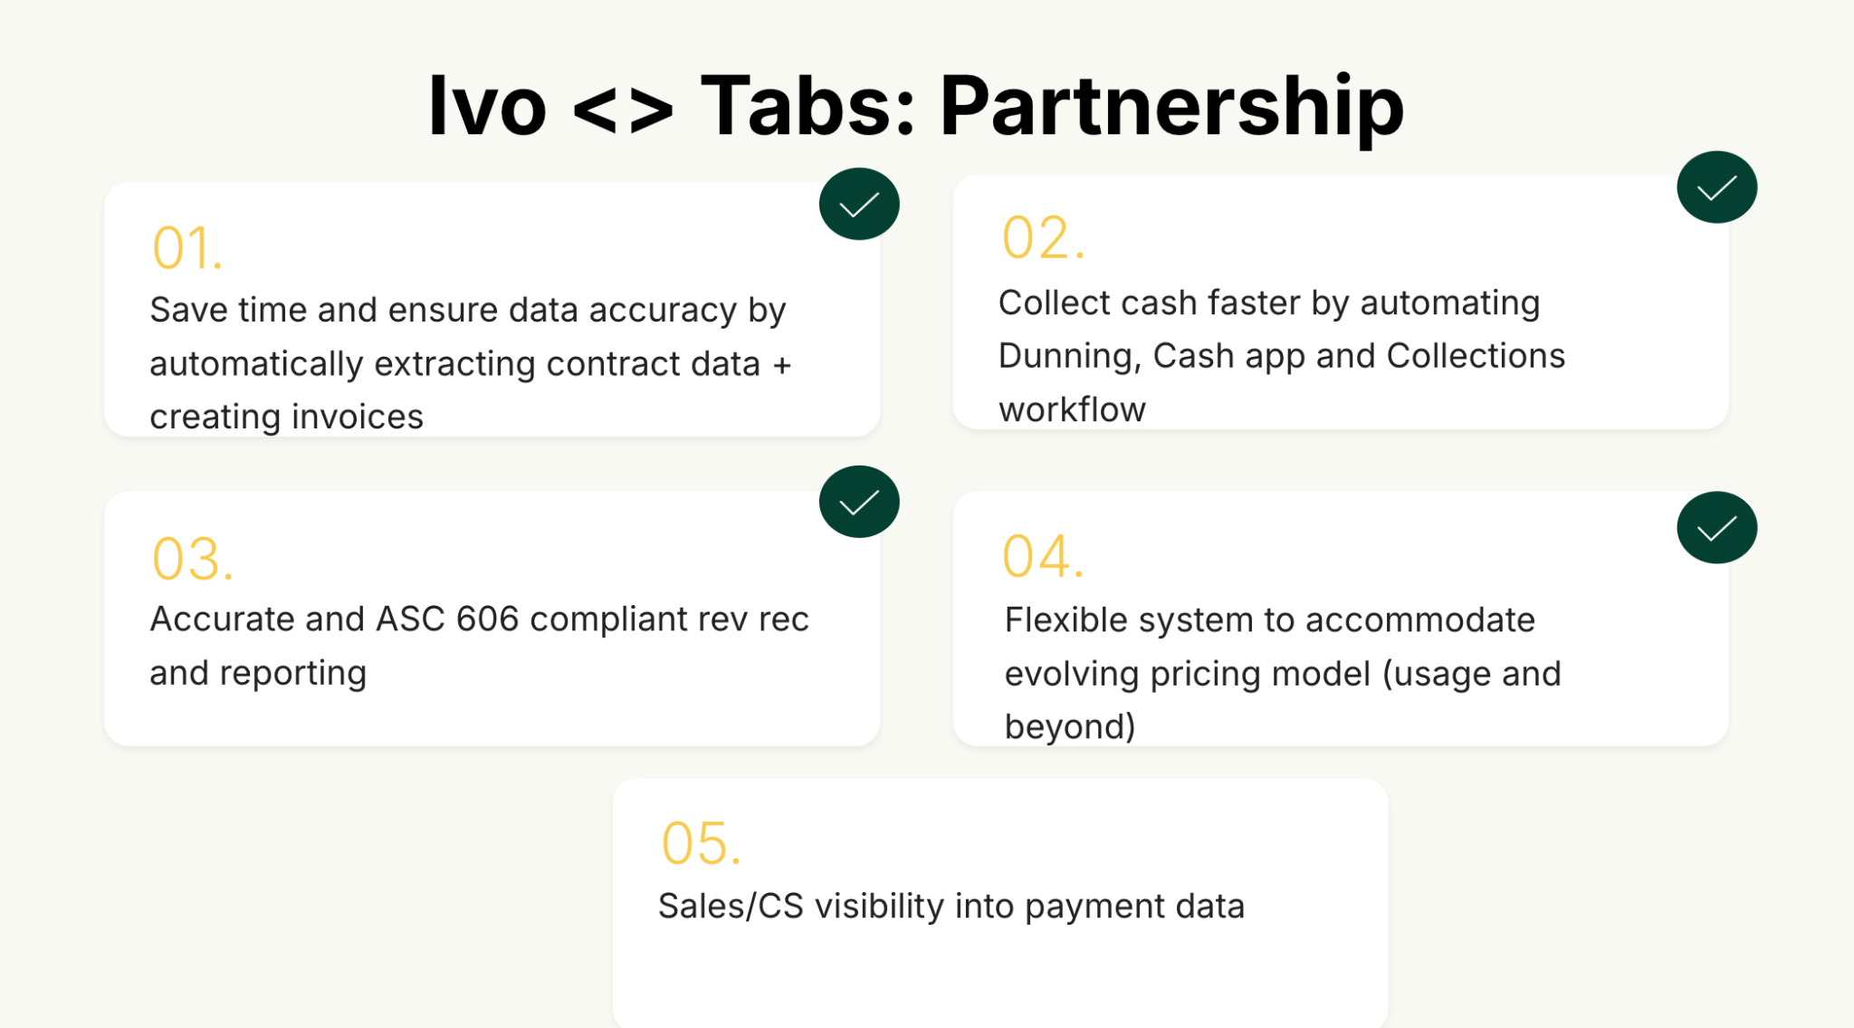

Is there an opt out clause? If so, what is the merchant looking for so they do not exercise it?

No

### Billing model *(AE/ Implementation to fill)*

* Are there unique things about the customer creation process for this merchant?  
  No, they have all their contracts ready to go in a google drive folder
* Information on how merchant bills
* How contract is broken up
* One off things to know about the merchant

Tabs → SFDC standard integration

### Contract Processing Steps *(Implementation/Success to fill)*

1. Steps to process
   1. Pull customer address + email from contract to customer billing information
      1. Latch was their old name so if you see that in contracts you can know its not one of their customers
   2. Service Start Date: Refer to the "Effective Date" on the SaaS Service Agreement.
   3. Months of Service: Refer to the Initial Term.
   4. Item Name: Under Name of License in the Service Fees section.
   5. Item Description: Leave blank.
   6. Integration Item: Leave blank.
   7. Billing Type: Flat Fee.
   8. Total Price: Under Total Fee in the Service Fees section.
      1. sum all discounts to one BT and have it just say "Discount"
         1. Integration item: Discount
         2. Class: 010-Revenue
         3. Category: Platform
      2. Anything that is not a discount but a BT, example: Ivo
         1. Integration item: IVO
         2. Class: 010-Revenue
         3. Category: Platform
   9. Quantity: Under Quantity in the Service Fees section.
   10. Start Date: Refer to the Invoice Period.
   11. Periods: Refer to the Invoice Period.
   12. Frequency: Refer to the Invoice Period.
   13. Net Terms: Refer to the Payment Period.
2. Anything to ignore in contracts?
3. Specifics processing things the merchant has requested that may differ by contract (e.g. always back-date invoice date to final day of the month)
4. Default Service Term
   1. If None Listed, Ops Default is 1 Year
5. Default Net Payment Terms
   1. If None, Ops Default is 30
6. Default Billing Frequency
   1. If None Listed, Ops Default is Annual
7. How do we handle taxes as a line item?
   1. If None Listed, Ops Default is every tax line item becomes a BT

### Events Processing (if necessary) *(Implementation/Success to fill)*

* Any important information on events billing

Integration Items Processing (if necessary)  
*(Implementation/Success to fill)*

* What are the instructions for assigning integration items?
* Example: All Statsig integrations items should be labeled as “Sales”
* Example: All “Pinata” integration items should be labeled as “Software Subscription Bundle” unless otherwise noted by Merchant

Post Processing Communications (if necessary)  
*(Implementation/Success to fill)*

* Does the Ops Team need to notify anyone on the team re: completion of processing batches in Implementation or Active phase?
* Who needs to be notified and when?
  + Example:
    - Who: Customer Success [Azmat Aziz] needs to be notified
    - Where: Messari internal merchant channel
    - When: contracts are processed [Merchant Phase: Active]

### Customer Information *(Implementation/Success to fill)*

* Any important information on specifics customers of this merchant
  + Special memo’s certain invoices require
  + Invoice changes due to merchant/customer relationship

### Feature Requests *(AE/Implementation/Success to fill)*

* FR 1
  + What is it
  + Why it's important
  + Urgency

### Rewatch Calls *(AE/Implementation/Success to fill)*

Intro <https://us-56595.app.gong.io/call?id=6224964495249540351&account-id=8465381708941449605>

Demo

<https://us-56595.app.gong.io/call?id=2146577055349389670&account-id=8465381708941449605>

Pricing, implementation, and cs

<https://us-56595.app.gong.io/call?id=4486519514983428235&account-id=8465381708941449605>

Final pricing negotiation

<https://us-56595.app.gong.io/call?id=9164888570636868884>